PJM6005

Week 4 – Group Assignment: Work Breakdown Structure (WBS)

WBS requirements:

L1 – Project Name

L2 – 4-6 major deliverables

L3 – 4 sub-deliverables for two L2s

L4 – 5-10 work packages for two L3s (10 max)

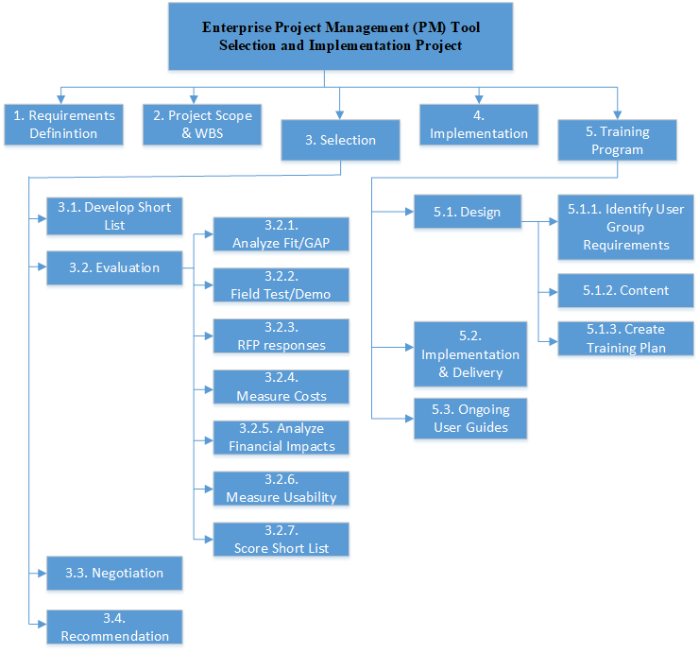

L1 – Enterprise Project Management (PM) Tool Selection and Implementation Project

1. Requirements Definition *[Jim WBSD]*
2. Project Scope & WBS
3. Selection *[Jim - WBSD]*
   1. Short List
   2. Evaluation
      1. Fit GAP
      2. Presentations / Demos
      3. RFP response
      4. Cost
      5. Financial Analysis
      6. Usability
      7. Scoring
   3. Negotiation
   4. Recommendation
4. Implementation *[Will WBS Dictionary]*
5. Training program *[Will WBS Dictionary]*
   1. Design
      1. User Group Requirements
         1. “Critical stakeholders” analysis
         2. PMO analysis
      2. Content
      3. Training Plan
   2. Implementation/Delivery
      1. Train the trainers
      2. “Critical stakeholders”
   3. Ongoing user guides

|  |  |  |  |  |
| --- | --- | --- | --- | --- |
| WBS Dictionary | | | | |
| Code | Name | Description | Cost1,2 | Time |
| 1. | Requirements Definition | Gathering, categorizing, and prioritizing a comprehensive list of requirements for the PM Collaboration Tool. These are to include features, capabilities, integrations, costs, financial value, and useability. The output of this work will be a Requirements Document which will serve as the basis for the review and scoring of all tools to be reviewed in the Selection phase. | $15,000  [ROM  -10% to +50%] | 3 wk  [ROM  ±10%] |
| 2. | Project Scope & WBS |  | $15,000  [ROM  -10% to +50%] | 3 wk  [ROM  ±10%] |
| 3. | Selection | The selection of a new PM Collaboration Tool for TSG. Work involved includes reviewing a broad number of available tools, some of which are specified in the Scope Statement, using the Requirements Document as the basis for this review; identifying at least four finalists; subject finalists to robust analysis and testing; score all finalists; recommend a selection to the sponsor; and receive board approval for the selection. | $115,000 [ROM  -25% to +60%] | 23 wk  [ROM  -25% to +50%] |
| 3.1. | Short List | A minimum of four finalists to be subject to robust analysis and testing. Using the Requirements Document as the basis for the review of options, this short list will emerge from the review of a broad number of available tools, some of which are specified in the Scope Statement. | $5,000  [ROM  -30% to +10%] | 1 wk  [ROM  ±25%] |
| 3.2. | Evaluation | A robust analysis, testing, and scoring of the tools on the Short List | $95,000 [ROM  -25% to +50%] | 19 wk  [ROM  -10% to +75%] |
| 3.2.1. | Analyze Fit/Gap | Create a Fit/Gap analysis for each of the finalists on the Short List, assessing each tool against all Must Have and Should Have requirements in the Requirements Document | $10,000 [ROM  -25% to +10%] | 2 wk  [ROM  ±25%] |
| 3.2.2. | Vendors Present and Demonstrate and PMs Field-Test | Short List vendors conduct presentations/demos with Project Team, Advisory Team, and 4 selected PM team. Additionally, the 4 PM teams field test the tool on a simulated project. | $41,000 [ROM  -25% to +50%] | 8 wk  [ROM  -10% to +75%] |
| 3.2.3. | Evaluate RFP Responses | Receive, review, and evaluate an RFP from each Short List vendor. | $10,000 [ROM  ±25%] | 2 wk  [ROM  ±25%] |
| 3.2.4. | Measure Costs | Establish costs for each tool that includes the cost of procurement, training, and licensing for a 5-year period. | $5,000 [ROM  -25% to +10%] | 1 wk  [ROM  ±10%] |
| 3.2.5. | Analyze Financial Impacts | TSG Business Analysts examine the impact of each tool on project management efficiencies, resource allocations, cost-of-ownership, and business requirements with associations to TSG’s PM toolset. | $10,000 [ROM  -25% to +20%] | 2 wk  [ROM  ±25%] |
| 3.2.6. | Measure Usability | Assess the usability of each tool for the PMs, the PMO office, finance and accounting, and senior management. | $10,000 [ROM  ±25%] | 2 wk  [ROM  ±25%] |
| 3.2.7. | Score Short List | Using scoring criteria outlined in the Requirements Document, score each tool, providing scores for each category specified in the RD and a comprehensive score. | $10,000 [ROM  -25% to +10%] | 2 wk  [ROM  ±10%] |
| 3.3. | Negotiation | A round of negotiations with the vendors of the top two scoring tools. The focus of the negotiation shall be on improving the overall score of the tool, not necessarily solely or primarily cost. | $10,000 [ROM  -25% to +50%] | 2 wk  [ROM  ±25%] |
| 3.4. | Recommendation | A tool selection recommendation to the TSG board for approval. This recommendation shall carry with it the approval and endorsement of the Project Sponsor and the Advisory Team. | $5,000 [ROM  -25% to +10%] | 1 wk  [ROM  ±10%] |
| 4. | Implementation | Project Team familiarizes themselves with tool using a data sandbox and ensures all current PM tools, process guides, and templates are deployed into new PM tool. | $5,000  [ROM ±25%] | 1 wk  [ROM  ±25%] |
| 5. | Training Program | The design and implementation of training for TSG’s managers, all project sponsors, portfolio managers, program managers, project managers, and project team members. Also includes the identification and ongoing mentoring of advanced users. | $30,000 [ROM  -25% to +50%] | 6 wk  [ROM  -25% to +50%] |
| 5.1. | Design | Project Team designs the training program for the selected software tool for implementation. The program will be designed such that it does not interfere with current TSG PMO work and allows for Tim Inc. to identify advanced users through supervision or evaluations. | $15,000 [ROM -25% to +50%] | 3 wk  [ROM  -25% to +50%] |
| 5.1.1. | Identify User Group Requirements | Familiarize user groups with tool. Critical stakeholders and TSG’s PMO will analyze and provide feedback on new tool. | $5,000  [ROM  ±25%] | 1 wk  [ROM  ±25%] |
| 5.1.2. | Establish Training Content | Establish the activities and content needed to smoothly integrate the new tool into TSG PM operations and supervise and/or evaluate users. | $5,000  [ROM  ±25%] | 1 wk  [ROM  ±25%] |
| 5.1.3. | Develop Training Plan | Sequence and schedule training sessions and further determine TSG critical stakeholder key roles and responsibilities during implementation. | $5,000  [ROM  ±25%] | 1 wk  [ROM  ±25%] |
| 5.2. | Implementation / Delivery | Conduct training sessions for all TSG critical stakeholders. Advanced users are identified and trained. | $10,000 [ROM  –25% to +50%] | 2 wk  [ROM  -25% to +50%] |
| 5.3. | Ongoing User Guides | Advanced users continue to mentor the PM tool users to improve PM practices. Tim Inc. Project Team is available for consult. | $5,000 [ROM  –25% to +50%] | 1 wk  [ROM  -25% to +50%] |

*ROM Estimates

*Mike:*

* Provide a Rough-Order of-Magnitude (ROM) cost estimate for each defined work package
* Provide a ROM time estimate for each defined work package
* In 3-5 paragraphs, please provide an assessment on the value of an effective WBSD for managing the project’s scope

*Rob:*

**100% Rule:**

The WBS must make sure that all the work at each level of the structure totals the work on the next higher level (100% Rule). This is to make sure that every deliverable is completed. *(Project Management Institute, 2019).* It is also important to make sure that no work outside the project scope is included in theWBS *(Project Management Institute, 2017).*

The process of rolling all the work elements (100%) in the project, either up or down, at each level of the WBS ensures that the cost and time for the work elements accounts for each deliverable. This reduces scope creep since it will be clear when work outside of the scope is requested because it will not fit within the WBS (*Meredith, Mantel, 2017).* Once the project baseline is established any requests for work outside the project scope will require a change request that will be incorporated into the WBS if approved.

The WBS for the Enterprise Project Management (PM) Tool Selection and Implementation Project does meet the 100% rule requirements. The lowest level of work elements rolls up into the next higher level of work to complete the deliverable in its segment of the WBS. There will be additional breakdown of the lowest level of work elements once the final project requirements are approved to make sure each work element will total 80 hours of work or less.

***Reference:***

Meredith, Mantel, (2017*); Project Management in Practice (6th Edition); Wiley & Sons; ISBN: 978-1-119-29885-4 (PBK); ISBN: 978-1-119-29867-0 (EVALC); 4-4.*

Project Management Institute. (2017). *A guide to the project management body of knowledge (PMBOK guide); section 5.4.*

Project Management Institute (PMI), (2019*). Practice Standard for Work Breakdown Structures, 3rd ed.; ISBN 978-1628256192.*

*Average Hourly Wage of a Project Manager;* $32/hr.

<https://www.salary.com/research/salary/benchmark/project-manager-i-hourly-wages>

*Average Maine Senior Project Manager Salary;* $104,442. (<https://www.glassdoor.com/Salaries/maine-project-manager-salary-SRCH_IL.0,5_IS758_KO6,21.htm>

*Average Maine Project Manager Salary;* $77,321/yr. <https://www.glassdoor.com/Salaries/maine-project-manager-salary-SRCH_IL.0,5_IS758_KO6,21.htm>

*Average Cost of Project Management Software;* $25/user/mo.

<https://www.betterbuys.com/project-management/project-management-pricing-guide/,> and <https://tech.co/crm-software/salesforce-pricing-how-much-does-salesforce-cost>

**Potential Project Tradeoffs:**

Managing tradeoffs by adjusting the project scope, schedule, or cost to satisfy the project stakeholders and business objectives of the project is one of the most important parts of the Project Managers job *(Meredith, Mantel, 2017)*. This project may require tradeoffs for important parts of its objectives before it is completed.

**Potential Project Tradeoffs**:

The selection processes for the project management tools focuses on the requirements of the stakeholders. The selection matrix established to access the potential PM tools may be biased towards certain stakeholders. It may be necessary to extend the time for this process in the project if it becomes evident that the bias is significant enough to require changing the matrix to satisfy the project sponsor or other stakeholders once the selection process has started. The tradeoff for this issue could be reducing the time for designing training or increasing resources (cost) to focus on training. We could also reduce the scope of the training goals by designing one training program to be applied to all users rather than focusing on distinct levels of training.

The time to complete the full integration of the new program management tools may take more time than planned if the software selected allows for significant customization. This may require the project team to commit additional resources for designing, testing, and implementing the customized features. A tradeoff for extensive customization may be committing additional resources for programing. We may be able to tradeoff training time since the customization may allow the new tools to align more easily with the current training within the PMO.

The training program may need to be expanded if the selected tools do not integrate well with the third-party products/software currently being used by the PMO or other areas of the company. This may require expanding time needed to design and implement the training program. It may be possible to reduce time for the training deliverables and still stay within the project scope if the selected tool includes a training “wizard” functionality that allows users to train themselves efficiently and effectively once they have basic training *(Kliem, R. L. 2000)*.

***Reference:***

Project Management in Practice; Meredith, Mantel, (2017); (6th Edition); Wiley & Sons; ISBN: 978-1-119-29885-4 (PBK); ISBN: 978-1-119-29867-0 (EVALC)

*Kliem, R. L. (2000). Project management software: friend or foe? PM Network, 14(7), 76–78.*

Footnotes:

1. All cost estimates are Labor costs, rounded up to the nearest thousand to account for materials, equipment, services, and facilities costs.
2. Labor costs calculated for the Project Team at $161/hr: 3x Proj. Mgr +1x Sr. Proj. Mgr. (Average Maine Project Manager Salary = $77,321/52 weeks/30 hours= $37.1735576923/hr. Roughly $37/hr *3 project managers = $111/hr.)+(Average Maine Senior Project Manager Salary = $104,442 annual/52 weeks/40 hours= $50.2125/hr. Roughly $50/hr.) (1 week* $161/hr = $4,830, rounded up= $5,000/wk)